TYPES OF SOLUTION CHEMICAL REACTIONS
OXIDATION-REDUCTION REACTIONS
1. Red-Ox Reaction- a reaction where electrons are transferred between reactants

2. LEO the Lion Says GER
a. Loss of Electrons is OXIDATION
i. oxidation number increases from reactant to product

b. Gain of Electrons is REDUCTION
i. oxidation number decreases from reactant to product.

3. Oxidation Number (Oxidation State) – a method of keeping track of electrons gained by the substance reduced and lost by the substance oxidized.

4. Rules for assigning oxidation numbers
a. Atoms in their elemental form have an oxidation number of zero. Cu = 0
b. Monatomic ions have an oxidation number equal to their charge. K⁺¹= +1.
c. Nonmetals have negative oxidation numbers.
i. Oxygen is -2 in all compounds with the exceptions of peroxides in which it is -1
ii. Hydrogen is usually +1 with nonmetals
Hydrogen is usually -1 with metals
d. The sum of the oxidation number in an neutral compoud is zero.

Exercise 16
Assign oxidation states to all atoms in the following.
a. CO₂
b. SF₆
c. NO₃⁻
a. oxygen is -2 & carbon is 4
b. fluorine is -1 & sulfer is +6
c. oxygen is -2 & nitrogen is +5
5. Identifying oxidation and reduction
Al³⁺ + Zn → Al + Zn²⁺

Look at the reactants and how they change across the arrow
Al³⁺ →Al oxidation number goes down, gain of electrons, reduction

Zn → Zn²⁺ oxidation number goes up, loss of electrons, oxidation

Cl_{2 (g)} + 2 Na _{(s)} → 2 Na⁺ _{(aq)} + 2 Cl⁻ _{(aq)}
Substance oxidized _____ Substance reduced ____

6. Half Reactions – most redox reactions are broken down into the reduction half reaction and the oxidation half reaction. When added they make the complete reaction. This is done to show the movement of electrons between reactants.
Fe²⁺ + Co → Co²⁺ + Fe
Oxidation: Co → Co²⁺ + 2e⁻
Reduction: Fe²⁺ + 2e⁻ → Fe
3 Ag⁺ + Ni → Ni³⁺ + 3 Ag
Oxidation:
Reduction:

7. Balancing half reactions:

Au³⁺ + Fe²⁺ → Fe³⁺ + Au

a. Determine the reactant that has been oxidized and which has been reduced.. Write a half reaction and note how many electrons are moved. Put the electrons on the side of the arrow so the net charges are equal

Fe⁺² → Fe⁺³ + 1e⁻ Au³⁺ + 3e⁻ → Au⁰
+2 = (+3 + -1) (+3 + -3) = 0
Oxidation Reduction
Multiply each half reaction by the lowest common factor so the number of electrons of the oxidized half reaction and reduced half reaction are equal.
3(Fe⁺² → Fe⁺³ + 1e⁻) = 3 Fe⁺² → 3Fe⁺³ + 3e⁻
Add both half reactions Au³⁺ + 3e⁻ → Au⁰
3 Fe⁺² + Au³⁺ → 3Fe⁺³ + Au
Pb²⁺ + Fe²⁺ → Fe³⁺ + Pb

8. Importance of Redox Reactions
Oxidation-reduction reactions are vital for biochemical reactions and industrial processes. The electron transfer system in cells and oxidation of glucose in the human body are examples of redox reactions. Redox reactions are used to reduce ores to obtain metals, to produce electrochemical cells, to convert ammonia into nitric acid for fertilizers, and to coat compact discs.

When we drink a can of cola, we are taking in fuel molecules mainly in the form of the disaccharide sucrose, which is a form of sugar we quickly convert to glucose. Then, in a long series of enzyme-catalyzed reactions, we 'burn' the glucose molecules: we transfer electrons from glucose to molecular oxygen, oxidizing the carbon molecules to carbon dioxide and reducing O₂ to water:
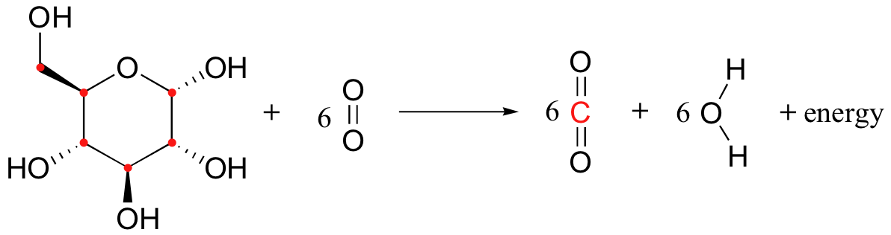
Glucose is a much stronger reducing agent than water (or, to put it in a more conventional way, O₂ is a much stronger oxidizing agent than CO₂). Therefore, the transfer of electrons from glucose to O₂ is a thermodynamically downhill, energy-releasing process, just like the transfer of electrons from zinc metal to copper ion. And while you could have used the energy released by the zinc/copper redox reaction to light a small light bulb (or to give your lab partner a nice little shock!), your cells use the energy released by the glucose/oxygen redox process to carry out a wide variety of energy-requiring activities.

